# Active Directory Simulation – CyberTech Solutions

This project is the deployment of a Windows Server Domain Controller (Active Directory) for a company called **CyberTech Solutions**. It includes domain setup, client configuration, OU design, group policies, and access control in an enterprise environment.
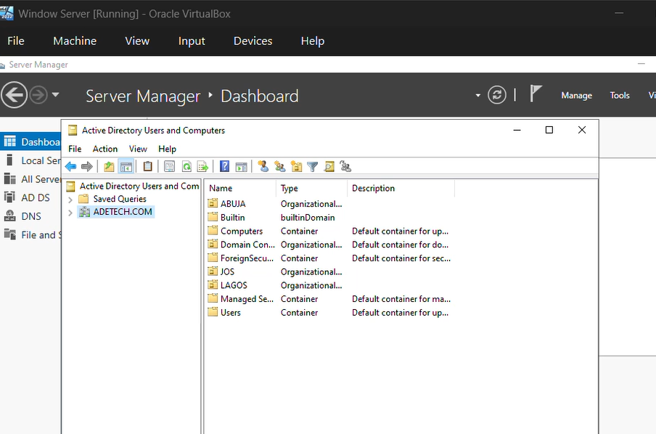

## Company Structure
**CyberTech Solutions** is a small IT services firm with the following structure:

- 1 x Windows Server (AD Domain Controller)
- 1 x Windows 8 Client PC (Account Department)
- 1 x Windows 8 Client PC (Legacy Software)
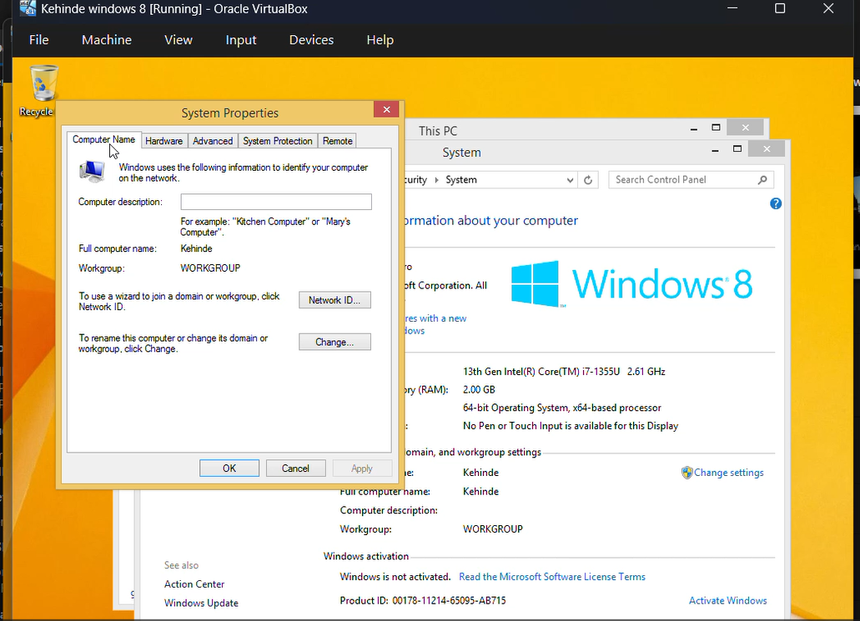

## Project Objectives
- Configure an AD Domain Controller on Windows Server
- Join client PCs to the domain
- Create Organizational Units (OUs)
- Implement basic Group Policies for access control
- Simulate a centralized IT environment
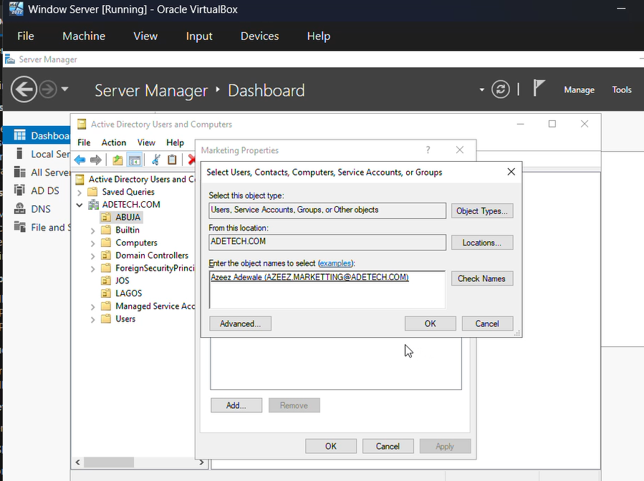
## Network Design
Internet
↓
Router (Gateway: 10.0.5.1)
↓
Switch
┌──────┬─────────────┬──────────────┐
│ │ │ │
Server PC1 (Win 8) PC2 (Win 8)
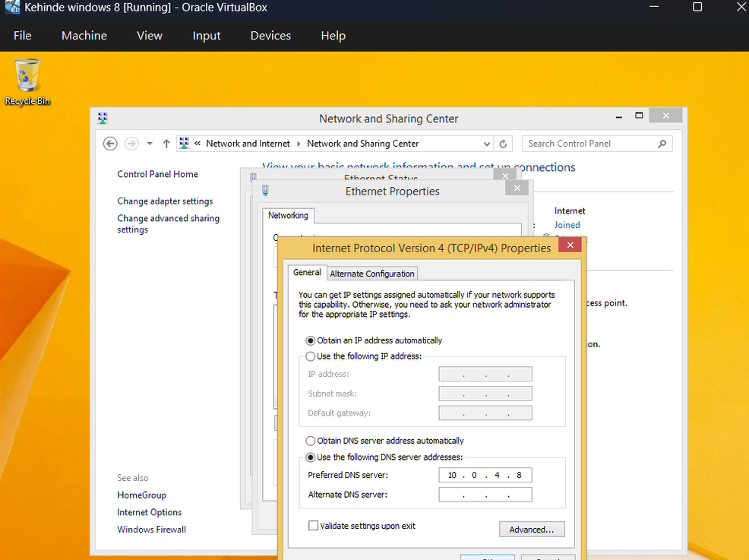

| Device | IP Address | Role |
|---------------|----------------|-----------------------------|
| Windows Server| 10.0.5.5 | AD Domain Controller (DC)
| Windows 8 PC | DHCP | Client (Accounts)
| Windows 8 PC | DHCP | Legacy Client

## Domain Configuration

- **Domain Name**: `adetech.com`
- **Server Name**: `ADETECH`
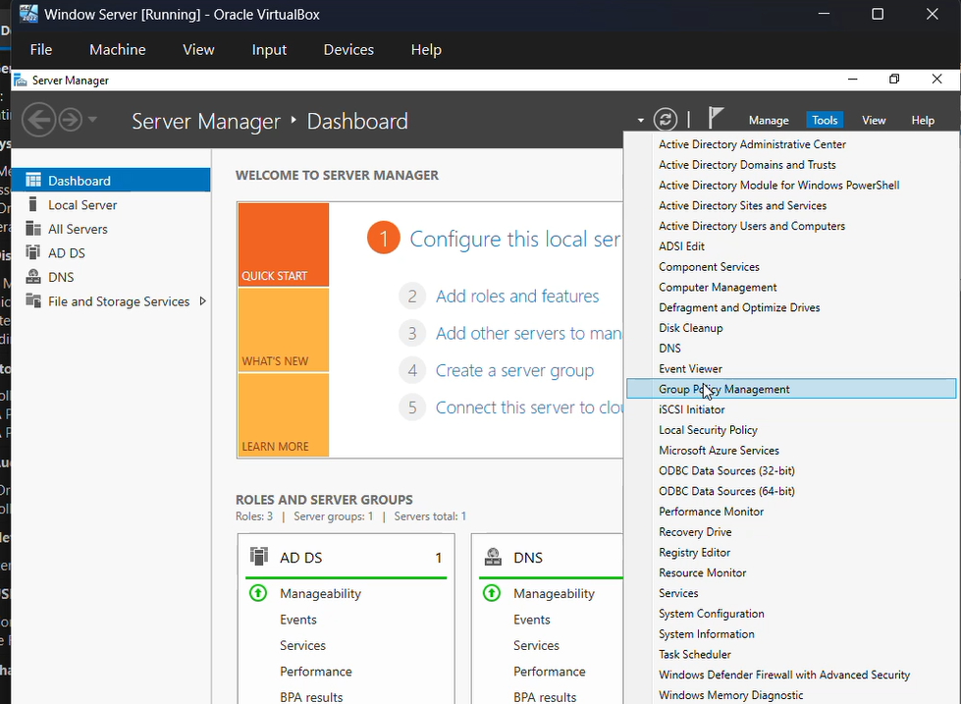
- **Static IP**: `10.0.5.5`
- **AD Roles Installed**: AD DS, DNS (DHCP)

## Organizational Units (OUs)

Created using **Active Directory Users and Computers**:
Adetech.com
├── OU: IT Department
│ └── Users: Elias.IT

├── OU: Sales
│ └── Users: Azeez

## Group Policy (GPO)

Created and linked using **Group Policy Management Console (gpmc.msc)**:

- **GPO Name**: `DisableRemovableDrives`
- **Linked to**: OU: IT Department
- **Policy Configured**:
- `Computer Configuration` > `Administrative Templates` > `System` > `Removable Storage Access`
- Set **"All Removable Storage classes: Deny all access"** to **Enabled**
Result: USB and external drives are disabled for all users in the **Accounts OU**.

---

## Screenshots

- AD Domain Structure
- GPO Editor Screenshot
- PC joined to domain
- Result of denied USB access
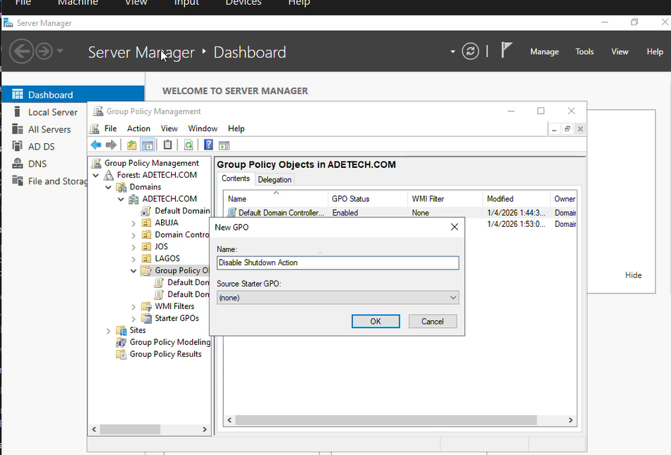

## Key Takeaways

- Gained practical experience with Windows Server roles and domain setup
- Implemented centralized access control using Group Policy.

